Generating Reports

Creating a Single Level Group By Report
This example creates a report that lists all of the samples assigned to each user.
See 'Data Visualizations' for details of opening the 'Reports' drop-down menu.
Briefly: Click on 'Project' in the top left corner to move to the Project page. The icon for opening the 'Reports' drop-down menu is on the right side level with the 'Summary' heading (Illustration 1: The 'Reports' drop down menu on the 'Project' page).
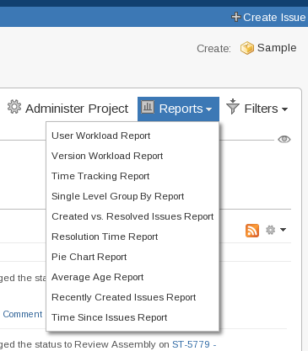
Illustration 1: The 'Reports' drop down menu on the 'Project' page

For the example select 'Single Level Group By Report'. This will open a new page containing a form (Illustration 2: The settings for generating a 'Single Level Group By Report')
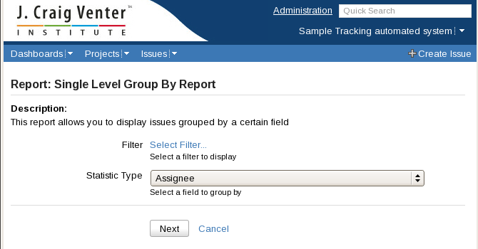
Illustration 2: The settings for generating a 'Single Level Group By Report'
The options are:
Filter
Unlike the filter selector in the pie charts example there is no option it directly pick a project. The same effect can be achieved by creating a filter that only selects the project wanted.
Statistic Type
Set to 'Assignee'
Clicking 'Next' will open a page containing the requested graph (Illustration 3: Single Level Group By Report of filter 'Samples in Sample Tracking' and field 'Assignee'), this may take some time.

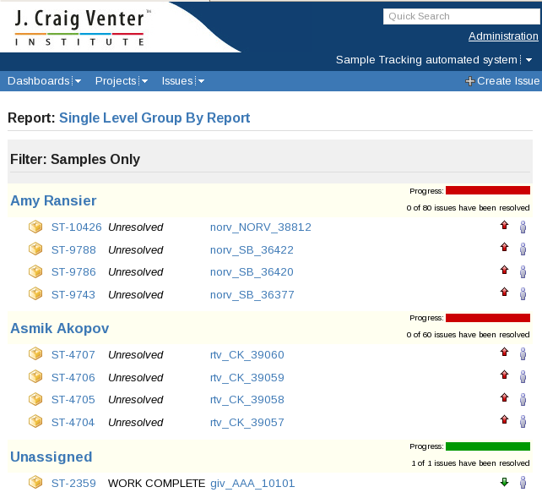
Illustration 3: Single Level Group By Report of filter 'Samples in Sample Tracking' and field 'Assignee'
The output of the report is somewhat verbose but it does include all of the data. The screenshot in illustration 3 has been modified to only display parts of the whole report.
Below the progress bar the total number of issues in that group are listed; 80 for Amy, 60 for Asmik and 1 Unassigned Sample in the report above.

